Human Reproduction

Male System
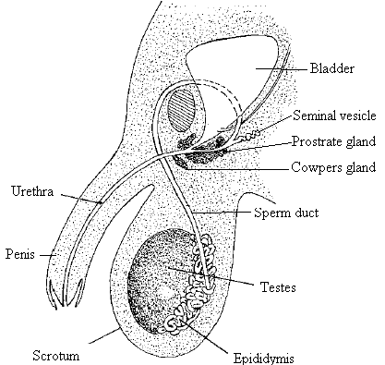Testes produce sperm by meiosis and secrete the male hormone, testosterone. The epididymis is a long coiled tube that receives and stores the sperm. The sperm Duct (Vas Deferens) transfers the sperm to the urethra. The seminal vesicle, prostate gland and the cowper’s gland secrete a sugar-rich fluid that allows the sperm to swim. The sperm and fluids form semen. The urethra carries urine and semen to the outside. Sperm has a haploid nucleus and a flagellum that propels it towards the egg cell. The middle piece or neck contains mitochondria producing the ATP to supply energy. The head contains the nucleus with the genetic material. It also has a large digestive enzyme sac, called the acrosome.

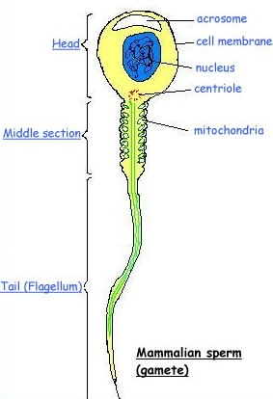Female System
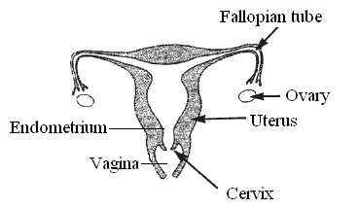The ovaries produces the female gametes, the egg cells. At ovulation the egg cell is released from the ovary. The fallopian tube captures the egg cell at ovulation. The fusion of sperm and egg cell into a zygote is called fertilisation. Fertilisation of the egg cell usually occurs in the Fallopian tube. The ‘fertilised egg’ is carried to the uterus. The ‘fertilised egg’ reaches the uterus in about six days. Sperm have been known to survive in the Fallopian tube for at least six days. The uterus or womb is the site of menstruation, implantation, development of the embryo and labour. A new uterine lining (endometrium) develops each cycle to receive and nourish the early embryo. The cervix is a narrow opening between the uterus and vagina. A solid mucus plug protects the uterus from pathogens. This mucus softens at the time of ovulation to allow the entry of sperm.
The vagina receives the penis during sexual intercourse.
Each month cells called oocytes develop in the ovary to form graafian follicles At the same time the ovary produces the hormone oestrogen. The graafian follicle produces an egg cell by meiosis. The mature graafian follicle ruptures at the surface of the ovary releasing the egg cell during ovulation. The empty graafian follicle becomes the corpus luteum which produces progesterone.
Secondary Sexual Characteristics
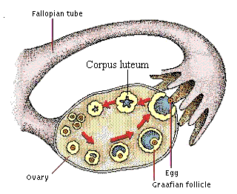These are the features that distinguish the sexually mature individual from the immature. They appear at puberty as a result of new higher levels of oestrogen in females and testosterone in males.

Male Secondary Sexual Characteristics | Female Secondary Sexual Characteristics
Hair growth on the face and pubic region | Hair growth in the pubic region and underarm
Penis enlarges | Enlarged breasts
wider shoulders | Wide hips

Menstrual Cycle
The menstrual cycle is the repeating series of changes in the uterine lining of a fertile female, over 28 days, if fertilisation and implantation does not happen.
Day 1 is the first day of menstruation. The corpus luteum of the previous cycle has disintegrated. The levels of oestrogen and progesterone have dropped. Low progesterone level leads to menstruation. Menstruation is the breakdown and discharge of the uterine lining out through the vagina. Low oestrogen and progesterone levels permit the secretion of FSH (follicle stimulating hormone) by the pituitary gland. From day 6 onwards FSH stimulates the formation and maturation of a Graafian follicle. The maturing follicle secretes oestrogen. Oestrogen inhibits FSH secretion preventing other follicles maturing. Oestrogen also stimulates repair of the uterine lining. Increased levels of oestrogen brings about the secretion of LH (luteinising hormone) just before ovulation. The surge of LH stimulates ovulation at Day 14. Ovulation is the release of the egg cell from the mature Graafian follicle at the ovary’s surface. The egg cell is drawn into the Fallopian tube.

From day 15 a corpus luteum develops from the ‘empty’ Graafian follicle. The corpus luteum secretes progesteronewhich stimulates the final maturation of the uterine lining. If implantation does not take place by day 27 the corpus luteum disintegrates and the uterus lining starts to break down.

Fertilisation
During sexual intercourse the male penis becomes filled with blood and is erect enough to enter the vagina. During ejaculation up to 500 million sperm are released into the vagina at the cervix. Sperm swim to the fallopian tube where fertilisation may occur if an egg is present. The fertilised egg or zygote divides by mitosis to form a ball of around 100 cells called the morula. The morula becomes a hollow ball of cells called the blastocyst. The blastocyst contains an inner mass of cells and an outer layer of cells called the trophoblast
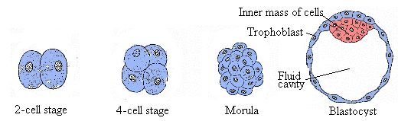The inner cell mass forms the three primary cell layers ectoderm, mesoderm, endoderm.
Each primary cell layer gives rise to specific new tissues and organs. The ectoderm forms skin epidermis and nervous system. The mesoderm forms skeleton and muscles. The endoderm forms the lining of gut, pancreas, thyroid and lungs.

Implantation is the embedding of the blastocyst (early developing embryo) into the uterine lining Implantation occurs about six days after fertilisation.

The Placenta
The placenta is made from tissues of the mothers endometrium and the trophoblast from the blastocyst. It allows an exchange of oxygen and carbon dioxide between the mothers and babies blood. The placenta allows food to be exchanged to the babies blood and wastes to be taken back into the mothers blood. The placenta is connected to the embryo by the umbilical cord. Two arteries and a large vein are present in the umbilical cord. The arteries carry blood from the foetus to the placenta. The vein carries blood from the placenta to the foetus. As the embryo develops it is cushioned by amniotic fluid inside the amniotic sac
Birth
The pituitary gland secretes oxytocin hormone which stimulates the contraction of the uterine muscles The contraction of these muscles brings about the dilation of the cervix. Dilation is the gradual widening of the cervix to allow safe passage of the head into the vagina. The amniotic sac ruptures and the amniotic fluid escapes by way of the vagina. The baby passes from the uterus through the cervix and along the vagina to the outside The umbilical cord is clamped closed near to the baby the cord is cut on the far side of the clamp The placenta is detached from the uterine wall and is pushed out as afterbirth.
Lactation is breastfeeding the baby with milk. The placenta produced very high levels of oestrogen and progesterone. After the birth of the baby these hormone levels fall rapidly. This decline allows the pituitary to secrete prolactin hormone. Prolactin stimulates the glands in the breasts to produce milk. The suckling of a baby at the breast stimulates the mother’s pituitary to release more prolactin. Human milk contains a wide variety of beneficial chemicals that include mother’s antibodies which protect the child against common pathogens.
Infertility
Infertility is the inability to produce children. Male infertility can be caused by low sperm count, low sperm motility or low testosterone level. In females ovulation may not occur due to hormone imbalance or the egg cell may not be able pass to the uterus due to blockage of the Fallopian tubes. In-vitro fertilisation and implantation is often used to treat infertility.

In-vitro Fertilisation
Hormone treatment induces the female to mature many graafian follicles. The egg cells are extracted from the follicles. The eggs cells are fertilised in a glass container. A few days later one or more normal pre-embryos are placed into the female’s uterus.

Menstrual Disorders
Fibroids are non-cancerous growths in the wall of the uterus. Fibroids cause heavy or prolonged menstruation. Fibroids may result from hormone imbalances and are treated by surgery and hormone therapy

Family Planning
Family planning is a conscious action to control the number of and interval between children.
Contraception is the deliberate prevention of fertilisation or implantation.
Natural Methods No sexual intercourse during the most fertile period of the menstrual cycle:
Mechanical methods Condom: a thin sheath covering the penis which prevents sperm entering the vagina. Cervix Barriers: diaphragm or cap – prevents sperm entering the uterus:
Surgical Vasectomy: cutting, sealing or tying off the sperm ducts; sperm will not be in the semen. Tubal ligation: the Fallopian tubes are cut and sealed preventing sperm and egg cells meeting:
Chemical Oral contraceptive pill: prevents ovulation

